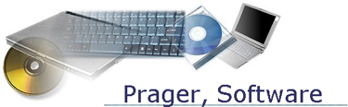

Prager Pricing Program

Installation Instructions:

Download:

Step 1

Go to the Microsoft website to download the prerequisite components (Windows Installer version 3.0 and NET Framework 2.0). NOTE: there is no charge from Microsoft for this software.

Step 2

Now, download the Prager Pricing program file to your hard drive by going to our web site and click on the line marked Prager Pricing Program - Complete to automatically download the file to your computer’s hard drive.

When the download has completed, double-click on it and the final part of the installation will start. When the installation has completed, click on the program icon on the desktop (or go to the Start Program menu) to start the program.

How to use this program:

Enter up to 20 ISBN’s in the textbox on the right (one per line) and click Search… that’s all there is to it… however, if you are running Windows Vista, you need to know the following:

Running this program under Windows Vista:

It has been brought to our attention that when running our programs under Windows Vista, you constantly have to give "administrator rights" to the program to run. This is a new function of Vista, but we have found a workaround...
Marking the application with "Run this program as Administrator"
You can mark any programs needing Administrator privileges by:
1. open Windows Explorer
2. go to c:\Program Files\Prager
3. find the Prager Book Inventory.exe program
4. right click on the name
5. Open file properties,
6. go to Compatibility, and
7. select the "Run this program as Administrator" check box
Vista should no longer ask you if you want to run this program as administrator.

